**Configuring Jenkins Node with username and ssh key**

* Create a new redhat vm
* Enable password authentication for the redhat vm
* Create a jenkins user with sudo permissions
* Install jdk 11 and maven on redhat vm

sudo dnf install java-11-openjdk-devel maven -y

* Now login into jenkins server/master as jenkins user and create a key-pair

ssh-keygen

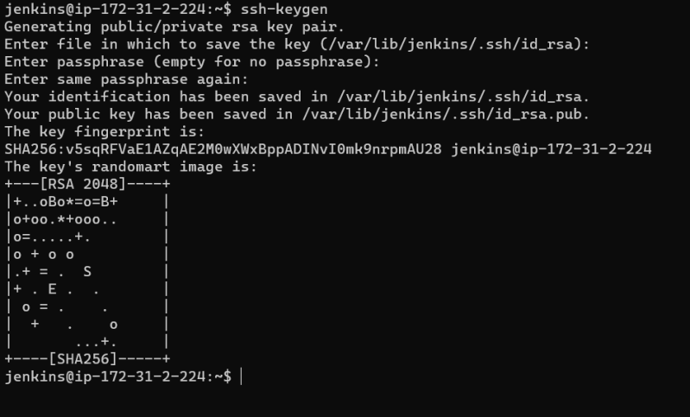

* Now copy the ssh-key (public-key) to redhat node using ssh-copy-id 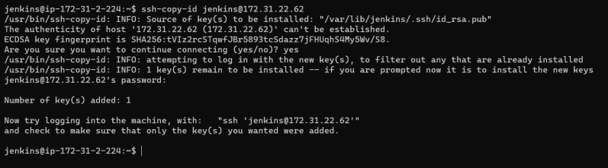
* Now jenkins master can login into redhat node with username
* Now lets configure the jenkins node (redhat) from manage nodes 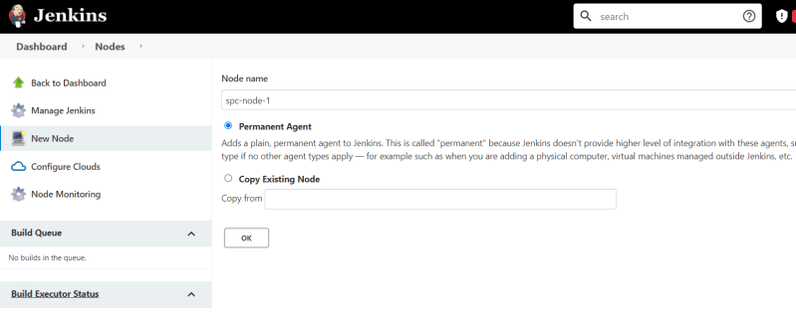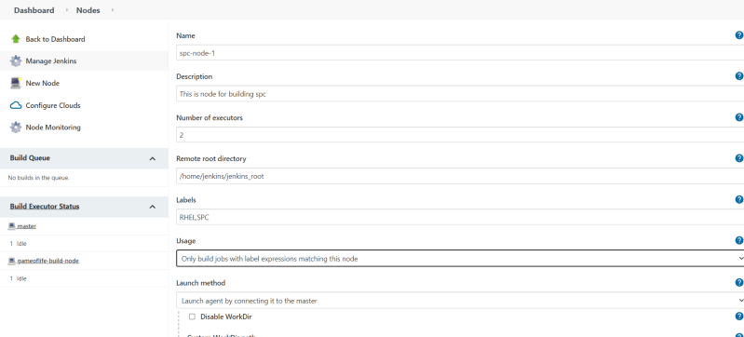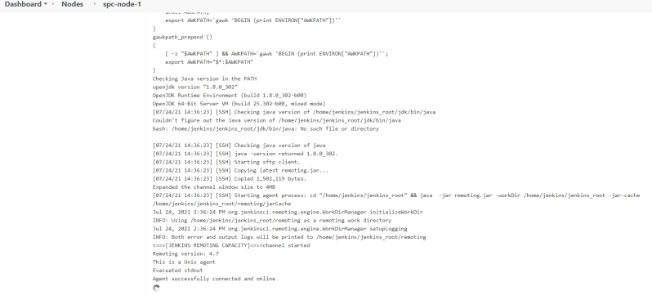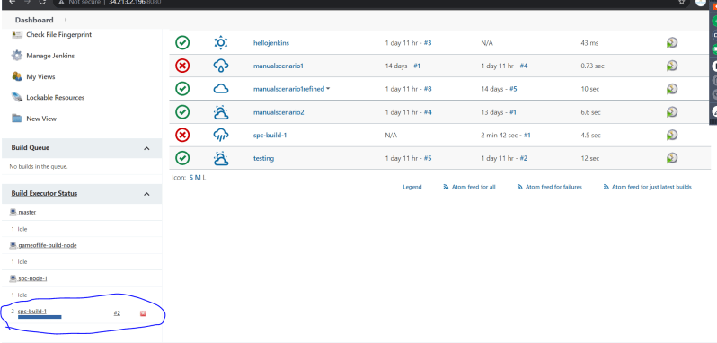
* Now we know how to add linux machines as nodes to the jenkins server using ssh.

**When to build the project?**

* In jenkins we can configure when to build the project using Build Triggers section 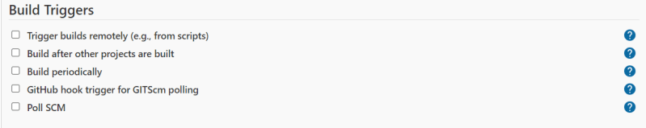
* Build after other project is build will lead to upstream and downstream jobs 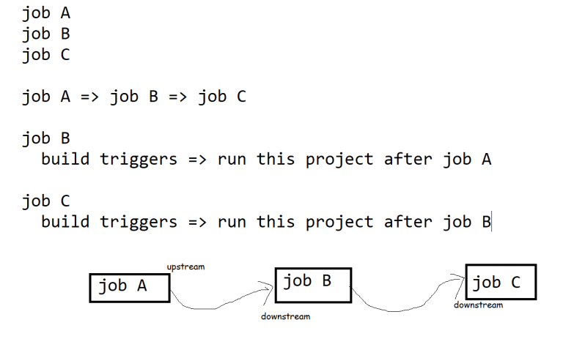
* Build periodically helps us in running jenkins job periodically like a cron job or scheduler. To configure this jenkins periodic builds the use cases might be
  + Build the project once in every hour
  + Build the project on every friday at 11:00 PM
* To configure Build Periodically we will have a cron sequence

MINUTE HOUR DOM MONTH DOW

* * * * * => every minute

* For working with cron expression
* Configure the job to run every hour 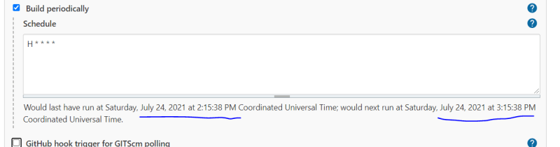
* Poll SCM => will build the project when there are some changes in the git repository. To configure poll scm we need to configure how frequently jenkins will poll git repository